**Purpose**

The Learner Disciplinary Procedure provides a framework for the regulation of learner behaviour.

**Scope**

All venues where training is delivered on behalf of LLS.

**Responsibility**

Managers, Tutors, Trainers, Assessors.

**Code of Learner Conduct**

The major principles that form the basis of acceptable learner conduct are:

* Learners are expected to respect and observe the rules and regulations of LLS
* Learners should conduct themselves in an orderly manner both in training centres, venues and at work placement
* Learners should always respect the rights and privacy of others

**Definition of Misconduct**

The following constitute examples of misconduct:

* Disruption of, or improper interference with, the academic, administrative, or other activities of LLS, whether on LLS premises or elsewhere
* Obstruction of, or improper interference with, the functions, duties or activities of any learner, member of staff or other employee of LLS or any authorised visitor to the LLS
* Violent, indecent, disorderly, threatening or offensive behaviour or language whilst on LLS premises or engaged in any LLS activity, including that committed by electronic means using email from a LLS account or any other account accessed via the LLS network
* Fraud, deceit, deception or dishonesty in relation to LLS or its staff or in relation to being a learner of LLS. This includes student malpractice and breaches of JCQ guidelines, including the improper use of AI. [1],[2]
* Action likely to cause injury or impair safety either on LLS premises or on any other sites associated with LLS through its professional or other programmes
* Defacement of, or deliberate damage to, any property of LLS, or any property of a member of LLS (including damage resulting from negligence)
* Acts of disturbance that threatens the rights and privacy of any member of LLS, whilst on LLS premises or engaged in LLS activity
* Harassment of any kind, including sexual or racial harassment of any learner, member of staff or other employee of LLS or any authorised visitor to LLS, including that committed by electronic or other remote means
* Acts of disturbance, negligence or breaches of health and safety measures which might threaten the safety, security or welfare of others
* Possession or misuse of drugs which constitutes an offence of the law

**Disciplinary Procedure**

**Informal Process**

The informal process is a Positive Engagement Agreement (see Appendix 1) which offers the learners a chance to change or modify their behaviour, in a supportive way, and should last for a maximum period of eight weeks. Areas for development are negotiated with the learners and are reviewed after a period of two weeks.

**Formal Process**

The formal process for serious or repeated misconduct is to be used when informal processes have failed to help improve behaviour and comprises of a 4-stage process.

**Stage 1 – Verbal Warning**

Given by a member of staff when conduct is unsatisfactory – this is logged on the Individual Learning Plan.

Where a verbal warning is insufficient, or previous warnings have not led to the necessary improvement

**Stage 2 – Written Warning**

* Formal disciplinary meeting will be held within 7 days
* The meeting will be made up of senior members of staff, and another member of staff who has not been involved.
* The learner can have someone with them for support (a parent or friend)- in the case of Study Programme a learner’s parent/carer must be present)
* The issue will be fully discussed
* The Learner will be informed of the outcome in writing within 7 working days
* The warning will be logged on the Learner file for a stated period, and will contain deadlines for improvement - an agreed support plan to be produced

Should the behaviour continue, or should the misdemeanour be serious

**Stage 3 – Final Written Warning**

This is kept on file until the end of the course, and any repeat of behaviour could result in the learner being asked to leave the course and could hinder progress to another course or study programme within LLS

**Stage 4 – Dismissal**

This will only be adopted in serious cases of misconduct, or when one or more of the above measures have been applied and have proved to be ineffective after a reasonable period of time.

**Exclusion and Suspension**

For serious misconduct, or where a cooling off period is required, learners may be suspended from training.

**Gross Misconduct**

This will lead to instant dismissal and listed below are an example of areas which may apply (these are not exhaustive)

* Theft from a training centre or centre of delivery, member of staff or other learners
* Unauthorised release of confidential information
* Serious acts of negligence
* Physical assault on members of staff, other learners or visitors
* Bringing drugs onto sites of delivery for own use or others
* Breach of Equality and Diversity policy
* Breach of SCC Health, Safety and Wellbeing policy

**Right of Appeal**

All learners have the right to appeal against any formal warning. This must be made in writing within 5 days of receiving a recorded warning.

**Forms / resources associated with this staff guidance**

Positive Engagement Agreement Form

Positive Engagement Flow Chart

**Student: Staff: Date: Review Date:**

|  |  |  |  |
| --- | --- | --- | --- |
| **Area for Development** | **Student Action** | **Supportive Action** | **Positive Outcome** |
| **1.** |  |  |  |
| **2.** |  |  |  |
| **3.** |  |  |  |
| **4.** |  |  |  |

|  |  |  |  |  |  |  |
| --- | --- | --- | --- | --- | --- | --- |
| **Day** | **1** | **2** | **3** | **4** | **5** | **6** |
| **Staff Comment** |  |  |  |  |  |  |
| **Learner Comment** |  |  |  |  |  |  |

|  |  |  |
| --- | --- | --- |
| **Review:** | **Date:** | **Review Number:** |
| **Outcome** | **Progress** | **Score (1-5 1 = No progress/regression 5 = Outcome met/remove target)** |
|  |  |  |
|  |  |  |
|  |  |  |
|  |  |  |
| **Summary of Changes (Including any new outcomes)** | | |
|  | | |
| **Actions** | | |
| Next review date set (if continuing):  Amended PEA agreed (if continuing):  Any other: | | |

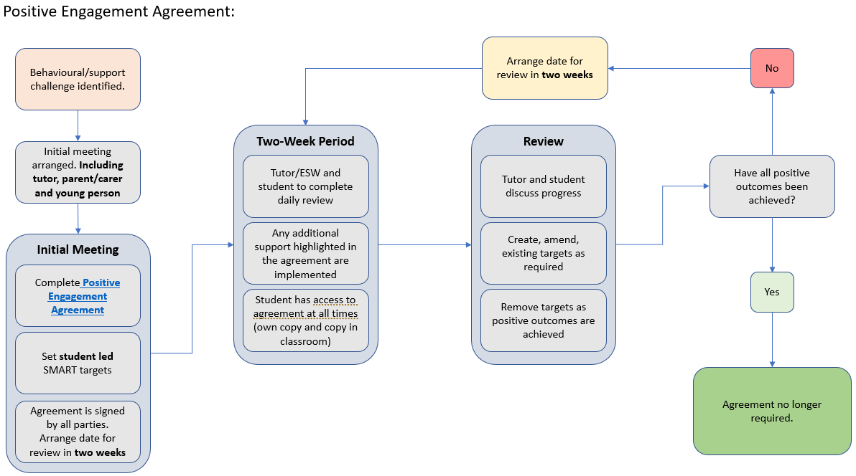

1. <https://www.jcq.org.uk/wp-content/uploads/2024/02/AI-Use-in-Assessments_Feb24_v3.pdf>
2. <https://www.jcq.org.uk/wp-content/uploads/2024/03/ICE_23-24_Final-March-2024.pdf>