

**Lifelong Learning and Skills**

**Early Years, Education and Skills**

**Sheffield City Council**

**Accountability Agreement 2024/2025** 

# Purpose

Sheffield Council’s **Lifelong Learning and Skills Service** will endeavour to take skills, knowledge, and experiences back to the wider society, communities, and families. Learning will enable further study, enhance employment opportunities, and embed a culture of positive participation in civic life.

# Vision

We aim to inspire present and future generations by transforming lives, building stronger and more cohesive communities, and by giving a voice to learners it will allow them to thrive and shape their own future. Through the delivery of outstanding teaching and learning we will build learners’ confidence, help them to develop resilience, improve their health and well-being, including mental health; inspiring positive progression pathways that will meet the needs of employers supporting them to boost Sheffield’s economy.

# Our Values

Learners are at the heart of what we do, enabling opportunity and success.

We provide high-quality education delivered with integrity and trust.

By working as one we achieve together.

# Context and Place

**Sheffield’s Lifelong Learning and Skills Service serves the 556,000 residents in what is the fourth largest city in the UK. We reach around 4,000 residents with our offer, working with adults, young people with SEND, and apprentices of all ages.**

Over 120,000 working age people have no qualifications or below level 2.

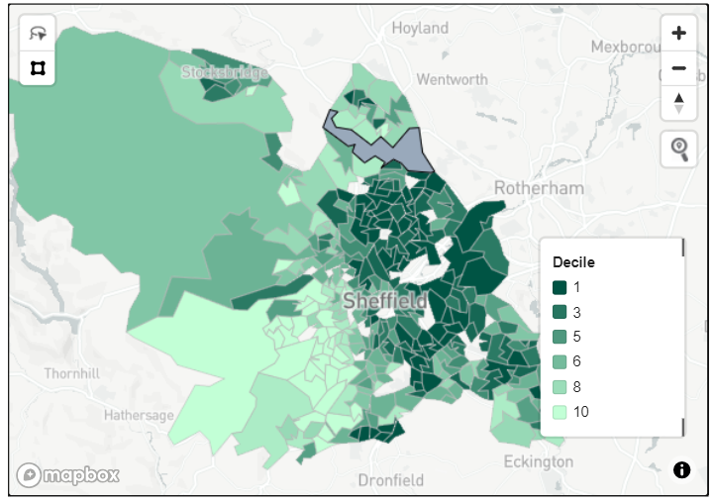

*Fig.1.IoD Adult Skills Sub-domain Rank (2019)*

Sheffield has some of the highest levels of deprivation impacting on education[1], skills and ultimately employment.

Sheffield[2] has 360,000 people of working age, which is 64.8% of the population. The most recent census outlines that 53% are economically active, but almost 13% are either carers, are long-term sick or have other considerations preventing them entering the workplace. Almost 29% of those in work, now work remotely, mainly at home.

Sheffield is a **City of Sanctuary**[3] and is proud of its diverse community, welcoming those seeking refuge and to settle, learn, and work in the region. Of the current Sheffield population, 15% are born outside the UK.

IMD 2019 highlights the high levels of Sheffield *(34%)* neighbourhoods that fall into the 20% of the most deprived in England. Specific areas of Sheffield have some of the highest levels in concentration of the most vulnerable and deprived – clustered in the centre, north, south, and east of the city, which is often replicated in every age cohort. Certain areas of the city have a concentration of rented or social housing with over 40% of the population living in the category, and potentially most impacted by the cost-of-living crisis.

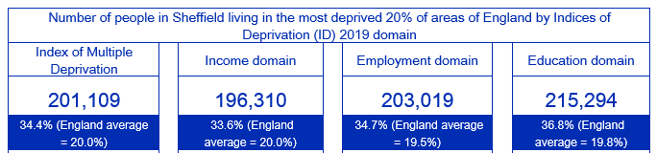*Fig.2. Source: Ministry of Housing, Communities and Local Government (Indices of Deprivation 2019)*

# Industry and Employment

**Sheffield has a long and prosperous reputation in the industry of steelmaking, known around the world for its cutlery and the invention of stainless steel. This, and more contemporary industries, are still recognised in key partnerships with Company of Cutlers in Hallamshire, supporting the delivery of aspirational careers and enterprise activity in schools.** They actively support many trade industries and manufacturers to recognise new talent for their workforce, and wholeheartedly connect young people to opportunities through their Education for Work[4] programmes in conjunction with Sheffield City Council[5] and Sheffield Hallam University.

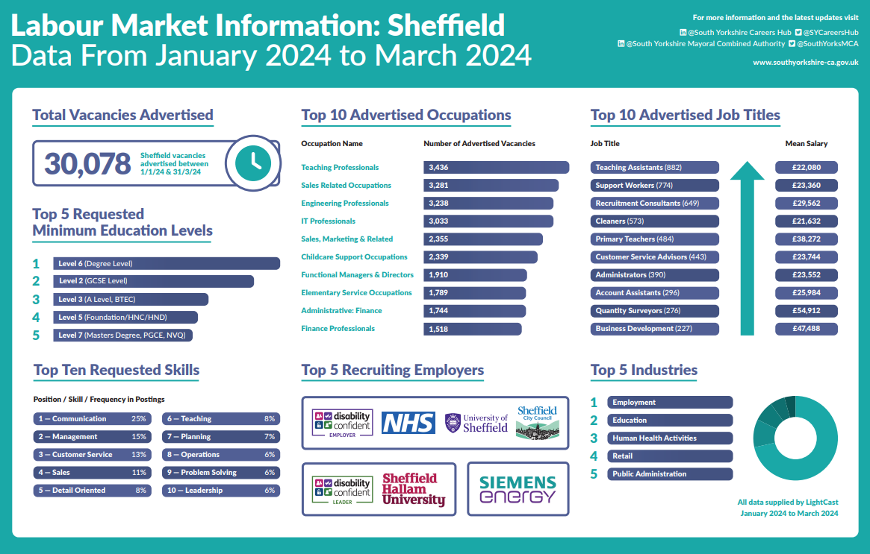

*Fig. 3 Top 3 Main Employment Sectors, Sheffield (LMI Apr 24)*

The **top employment sectors in South Yorkshire**[6] includes:

* Education
* Retail – particularly the motor vehicle industry
* Manufacturing/Engineering
* Health & Social Work

These are then followed by:

* Administrative & Support Services
* Professional, Scientific and Technical Activities

The **pandemic impacted greatly on the confidence of learners** to return to their studies, particularly adults and those with young children. This had a greater impact on those with the lowest skills who need to access foundation learning. Initiatives such as the National Multiply is welcomed and have been successful in Sheffield in helping to reassert confidence for learners with the most barriers.

**Apprenticeship vacancies** in the region have also reduced in number since the lockdown period ended, with availability at less than half that which was available were in early 2022. Most severely impacted are the intermediate level 2 apprenticeships which have reduced by 73% - making the first rungs of vocational learning and employment opportunities even harder for the 16-24 population. **NEETs in Sheffield**[7] are comparatively high to other core cities, with the concentration aligning to the most deprived wards of the city. It is recognised that the most vulnerable of the NEETs cohort need a renewed focus, and targeted work by the Service with those identified with SEND, is supporting a positive trajectory. This work will form part of a city-wide post-16 strategy, to focus on supporting those Not In Education, Employment and Training and being developed in partnership with a range of Council services.

# Future Goals and Opportunities

We believe that Sheffield is a ‘resilient and determined city’[8], and we are ambitious for its people. The city’s approach to co-productive partnerships to shape its future new economic plan, will aim to be more inclusive in delivering on the Council’s shared view for our ‘City Goals’. Sheffield has developed 18 goals which point towards 6 stories that we want to be able to tell in 2035, all of which are interlinked and are the foundation for our work in Lifelong Learning and Skills. We have highlighted some of the 18 goals below which we believe are particularly integral to our work as a service:

**A creative and entrepreneurial Sheffield.**

Sheffield will be a city where we all have opportunities to invent, make, create and build in ways that grow shared prosperity, create high-quality jobs and enrich our communities and ourselves. Key city goal for our service:

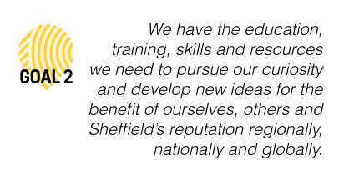

Lifelong Learning and Skills will develop and deliver education and training which supports residents to pursue their curiosity and fulfil their ambitions to move to further learning, towards employment and to support our communities.

**A Green and Resilient Sheffield**

Sheffield will be a city where we all act urgently on the climate and environmental crisis, prepare for a changing future, and prioritise the health and wellbeing of our city's people and nature

Key city goal for our service:

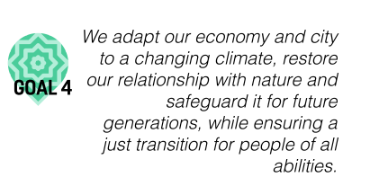

Jobs of the future continue to focus on energy usage, the green agenda and sustainability[9]. Although the demand for green skills in the employment market is growing faster than any other, entry for those with the lowest skills is still difficult. We will embed sustainability across our curriculum and deliver opportunities for those with the lowest skills in this area.

**A Sheffield for all generations:**

Sheffield will support all generations to flourish while remaining hopeful about the future, free from poverty and oppression and regardless of background.

Key city goal for our service:

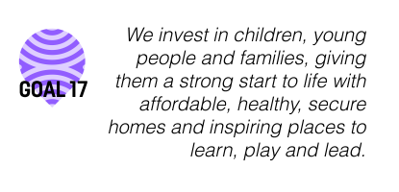

Sheffield is a vibrant University City, and one of the greenest cities in England. Family Learning and well-being will continue to utilise outdoor spaces for learning and local facilities. Our Young People will be part of a wide enrichment programme that will continue to address social and environment themes, give opportunities to volunteer in communities, and build an awareness of Sheffield’s history and future.

# Service Planning, Design and Development

The Service has a cyclic planning approach that is continuous in that it utilises key reporting points to assess design, development, and success. It begins and ends in October with Performance Management Review panels, and delivery for the following year is finalised and agreed in May of the outgoing academic year.

The Service assesses detailed analysis of national, regional, and local priorities. The Service ensures it takes account of Government policy plans and consultations with representation on active working groups such as the HOLEX[10] Policy Forum.

*Fig.4. The Planning**Cycle*

The Service is nestled within the wider Early Years, Education and Skills Portfolio in the City Council, with a direct connection and reporting line to the Economic Development and Skills Portfolio. This confirms the delivery focus is the Quality of Education but the contribution to the local and regional Employment and Skills is foremost within the strategic planning for the city. This utilises analysis and information produced by the Chamber of Commerce[11] and the Mayoral Combined Authority.

Governance is clearly set out within the Council systems and processes; at an operational level the Advisory Board ensures the service has the necessary support and challenge to remain purposeful for the citizens of Sheffield. To assure this it has the widest possible representation which includes: the Chamber of Commerce, local employer, community learning provider, teaching staff member, learner representative (currently an apprentice), and specifically represented themes such as the Council Prevent Team.

The voice of the learner remains at the heart of the planning process. There is a cycle to gather the views of all learners, apprentices, employers, and other stakeholders such as the Voluntary Community & Faith Sector (VCFS) and the wider community so that they are instrumental in future service development and improvement.

# Provision & Partnerships

To ensure the provision maximises funding to best meet the needs of learners and, considers limiting aspects of the barriers they face, the service continues to assess delivery sites against the mapping for deprivation (Fig.5).

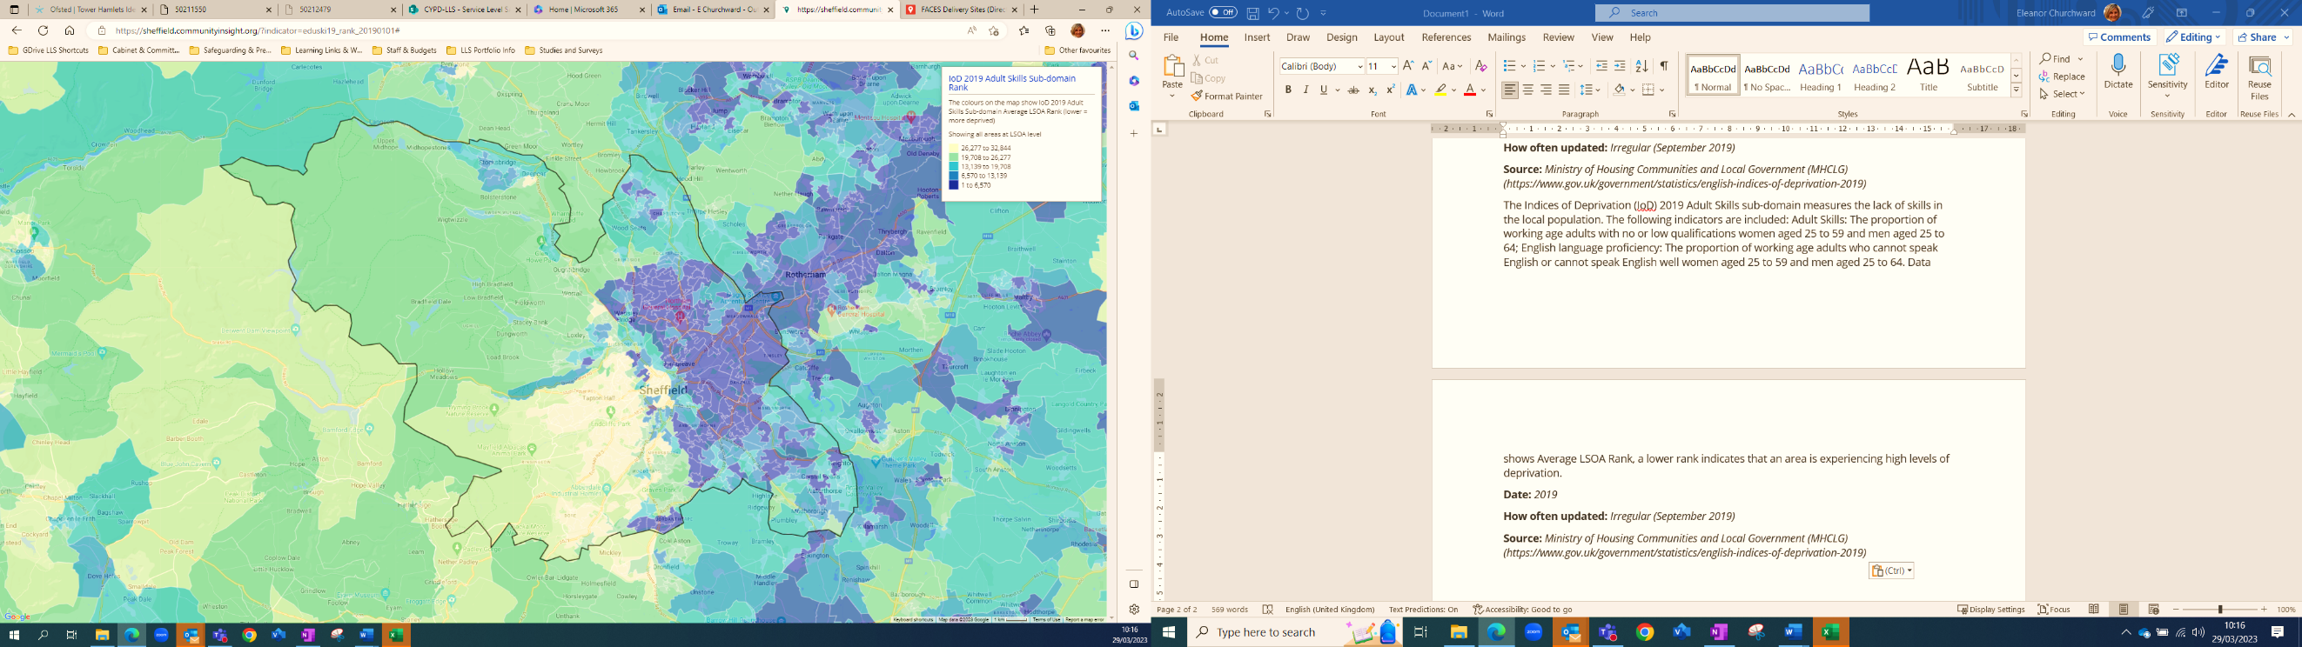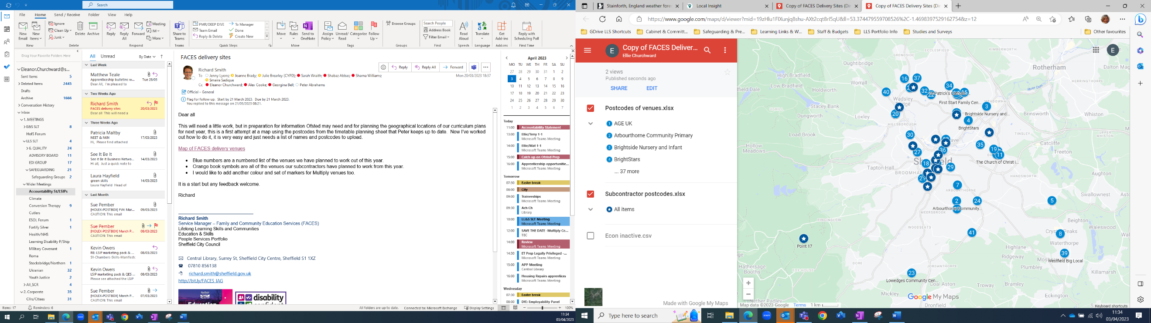

*Fig.5.LLS Service Provision - January 2023*

The recent pandemic followed by the economic and cost of living crisis has accentuated the most challenging barriers learners have faced in a generation.

**Specific considerations to removing barriers are:**

* Travel to learn is minimised by basing provision in the heart of communities most impacted by deprivation.
* Procurement of a range of learning providers with the skills, experience and understanding of their communities.
* Working with the Combined Mayoral Authority to secure additional and localised flexible learning support that enables participation and removes the most challenging barriers.
* Innovating new and/or contemporary approaches to provision so that we enable learners to gain currency in their skills to improve learning opportunities and prepare them for work in the 21st Century.[12]
* Ensuring provision is linked (fig.6) to stakeholder strategic planning[13] as this will be crucial to preparing those that are looking for work to the most appropriate opportunities and skills shortages.

# Aims, Objectives and Supporting the National, Regional and Local Priorities.

Our aims and objectives as a service are to deliver education provision which aligns to South Yorkshire Mayoral Combined Authority’s regional skills strategy[14] and its 3 key missions:

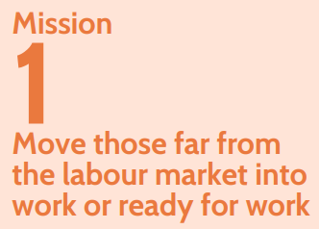Around 95,500 people or 24.7% of the population aged 16 to 64 years in Sheffield were "economically inactive" in the year ending December 2023. This compares with around 83,800 people (21.7%) in the year ending December 2022[15] Those who experience it often have multiple complex needs, are facing numerous barriers and feel a sense of isolation and hopelessness. Those with long-term health conditions, ethnic minorities, and young people with Special Education Needs and Disability (SEND) are all significantly more likely to be economically inactive. Within the labour market we also see certain groups consistently underrepresented in work, such as ethnic minorities.14

We must ensure our employment support offer and services are inclusive and engaging to all. Our offer of education and training in Lifelong Learning and Skills is designed to re-engage people into learning and support them to develop their confidence, restore hope and support their aspirations to progress into further learning, training and work-based programmes.

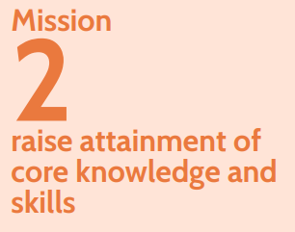

“Over 232,000 working age residents in South Yorkshire only have a Level 1 qualification or below, equivalent to 29% of the population aged 16-64. Language, literacy, numeracy, and digital skills are central to personal development and progression. We know that these core skills have an enduring importance not only in providing residents with confidence and a foundation for success, but also in providing resilience to the local economy as and when employment patterns shift. We need to raise the standard of language, literacy, numeracy and other basic skills amongst young people and adults. This includes supporting groups who are less likely to engage with the skills system. Provision must be accessible to the learner, offer a joined-up programme that meets the learners’ needs and ambitions and focused on taking the learner somewhere new, either new or better work or further learning (‘employment and progression focused’).”14 Lifelong Learning and Skills is committed to developing our curriculum with this mission and its goals are at the heart of what we deliver.

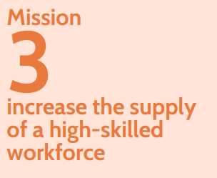

“South Yorkshire still experiences too large a ‘missing middle’ in its skills profile between university degrees and core skills. Providing these intermediate skills and reducing skills mismatches could offer a significant boost to regional productivity. We wish to support the pipeline of learning through to work based skills learning and to develop vocational skills and work-based learning. Apprenticeship starts have fallen since 2018/19, our curriculum and employer engagement work must support learners from all aspects of our delivery provision into work-based learning, supported internships, meaningful work experience or experience of work and high-quality apprenticeships.

|  |  |  |
| --- | --- | --- |
| **Strategic Aims** | **Service Objectives** | **Contribution to National, Regional and Local Priorities** |
| Enable all ‘Sheffielders’ to benefit from a connection to the best the city has to offer. | Those furthest from the employment market have lost confidence to return to adult education, therefore we will develop provision that will maintain a pipeline to progress into qualifications to give people the basic skills for employment. Beginning with engagement of learners through our Multiply Programme and activities that address wellbeing. We will deliver basic skills qualifications up to level 2 as these are a pre-requisite skill that will enable progression to higher levels of education and improve access to available employment.  Continue the development of new standards within our offer so that skills align to jobs for the 21st Century, we will aim to deliver a total of 20 Apprenticeships in Digital Technologies  All learners and apprentices will have access to digital skills and will be encouraged to gain digital competency. We will deliver 100 Essential Digital Skills Qualifications. | Basic maths and English underpin all national, regional, and local priorities. Language, literacy, numeracy, and digital skills are central to personal development and progression.  This will support SYMCA with its first and second mission and with Sheffield’s City Goals, specifically its first goal that we will build a fair, inclusive & creative local economy that attracts & retains talent, supports local businesses, and invests in opportunities for all.8  Sheffield LSIP highlights that we need to release the ‘hidden workforce potential in our communities’ by ensuring there is a digital offer event at the most basic level to connect all learners to the 21st Century.  Digital proficiency is a key component for a skilled workforce and is now an ‘essential functional skill’, as well as continuing to be a national skill priority**[16]**. |
| Support inclusive opportunities for all children, young people, and vulnerable adults | Maintain high achievement rates for all apprentices that will exceed the latest Government target of 67%.  We will have a targeted and supportive approach to the most vulnerable in society, particularly SEND and we will deliver 12 Supported Internships to enable access to employment.  We will engage more than 2000 adults in the national Multiply programme, ensuring at least half engage in meaningful learning and progression.  We will deliver ESOL programmes to 800 adults across our diverse communities, with progression into courses that deliver employment skills. | The gap of those qualified at level 3 in South Yorkshire[17] compared to national is widening.  Apprenticeship achievements have fallen nationally, and Sheffield Apprentice vacancies are at an all-time low. The service maintains a high expectation for all those in learning.  Sheffield has a high rate of NEETs/Not Known[18] at 6.8%, with many in the most vulnerable groups as well as those with SEND.  Sheffield Inclusion Strategy[19] has a clear vision that all young people be enabled to live happy and fulfilled lives, but they must be appropriately represented and supported to access the right provision at the right time.  Enable parents/carers to understand the benefits and opportunities for their children, themselves, for work and for their community. The city is diverse with 15% of residents born outside of the UK.  As a City of Sanctuary[20] Sheffield has many residents with little or no English. Our ESOL offer will enable residents to fulfil their potential and feel able to participate in their community. |
| Empower the voice and actions of all individuals to reach out for the very best, healthy & happy life. | We will design courses in collaboration with the sector and aim to increase the number of adults engaging in pathways that will enhance their well-being, and confidence.  Engaging in adult education for personal well-being can lead to career choices within this sector. We will ensure high quality IAG highlights appropriate employment opportunities within the care sector, our well-being offers will reach 300 adults in the city.  To support effective sector recruitment, we will work with employers to recruit and deliver 20 Child Care apprenticeships. | The census outlines that over 10% of the population provides care, and over 20% have less than ‘good’ health.    The Health and Social Care sector is a national skills priority, as well as one of the highest recruitment sectors with vacancies to fill in Sheffield.  The current Sheffield Council Plan 2024-28[21] outlines Sheffield’s ambition to be a creative and prosperous city full of culture, learning, and innovation where we Connect more people into the city’s prosperity with more good jobs, skills, training and better access to opportunities.  The childcare sector is struggling to recruit suitable staffing and maintain their workforce. They often cite support to find the right workforce, as well as funding as the main issues.  There is a recognised demand for the workforce around Childcare which will increase with the 9mth funding[22] for the future. |
| Embed an ethos of active citizenship that will help to build strong and inclusive communities. | Enrichment within our 16-19 Study Programmes will be a key focus in all curricula so that **every learner** will have the opportunity to develop new interests and explore their talents and gain transferable skills through social action, digital, participation in local culture and competitions.  Working with families to help them prepare their children for school, and embed stronger communities, we will create 100 opportunities for volunteering through learning activity.  Citizenship and community activity will be a key element of all activity undertaken by Young People to strengthen understanding of active democracy. We will ensure that 50 Young People can undertake some form of volunteering. | Sheffield’s recent Race Equality Commission[23] set out a clear set of priorities to stamp out racism in all its forms and ensure Sheffield truly embeds, Equality, Inclusivity and Diversity.  Sheffield SEND inspection[24] highlights poor transition at post-16.  Volunteering contributes an estimated £20bn to the national economy and is often a first step into paid employment for some, and a choice for others. |
| Advocate a greener and more resilient future for Sheffield. | We will deliver themes of sustainability and the green industries with our programmes of learning, to 200 Adults in community learning to encourage them to consider careers related to green jobs.  We will increase delivery in construction trades within our apprenticeships by 50%, which will recognise modern technologies, skills and materials that contribute to energy reduction, as well as aiding personal work progression. | The UK has a goal to lower greenhouse gasses to net zero by 2050[25].  To maintain Sheffield as one of the greenest cities in the UK the region is working together with business and communities on a range of green issues – research creating green jobs and greener travel strategies[26].  The average output of Sheffield workers was outlined in the LSIP as 20% lower than that of the UK.  Skills shortage job vacancies in Sheffield at 39% compared to 34% in England. |

# Statement

On behalf of Sheffield City Council, it is confirmed that the plan as set out in this document reflects an agreed statement of purpose, aims and objectives and is subject to scrutiny through our local governance structure, our LLS Advisory Board.

The plan will be published on the service’s website by the end of June 2024.

# [Family Adult Community Education | Sheffield City Council](https://www.sheffield.gov.uk/schools-childcare/family-adult-community-education)

[Home (lifelonglearningandskills.org)](http://www.lifelonglearningandskills.org/)

# References used to support this statement:

[Local Insight (communityinsight.org)](https://sheffield.communityinsight.org/?indicator=eduski19_rank_20190101)

[Local Area Report for areas in England and Wales - Nomis (nomisweb.co.uk)](https://www.nomisweb.co.uk/reports/localarea?compare=E34004969)

[Skills Builder Framework - Better Learners Better Workers](https://www.betterlearnersbetterworkers.org.uk/about/skills-framework/)

[See It Be It in Sheffield - Sheffield Chamber (scci.org.uk)](https://www.scci.org.uk/partnerships/campaigns/see-it-be-it-in-sheffield/)

[Employment sectors: South Yorkshire Labour Market Information - South Yorkshire MCA (southyorkshire-ca.gov.uk)](https://southyorkshire-ca.gov.uk/Explore_LMI_Employment-sectors)

[Sheffield City Goals](https://sheffieldcitygoals.uk/)

[Start - Advanced Manufacturing in Sheffield, Rotherham, Doncaster & Barnsley (startprofile.com)](https://southyorkshire.startprofile.com/page/southyorkshire-advancedmanufacturing)

[Future of jobs is green: Climate change is changing labour markets | World Economic Forum (weforum.org)](https://www.weforum.org/agenda/2023/04/future-of-jobs-is-green-2023-climate-change-labour-markets/)

[Holex |](https://holex.org.uk/)

[Local Skills Improvement Plans (LSIP) - Sheffield Chamber (scci.org.uk)](https://www.scci.org.uk/partnerships/education-and-skills/local-skills-improvement-plan-lsip/)

[GEIS2016-Background-document.pdf (oecd.org)](https://www.oecd.org/education/ceri/GEIS2016-Background-document.pdf)

[Insight Q1 2023 - Infogram](https://infogram.com/1pjzvrjmdq0m9rb6lz22dd9v6vamdk7kgvd?live)

[Sheffield Inclusion Strategy, 2020-2025](https://democracy.sheffield.gov.uk/documents/s38350/Sheffield%20Inclusion%20Strategy%202020-2025.pdf)

[Home - City of Sanctuary Sheffield](https://sheffield.cityofsanctuary.org/)

[Our Sheffield Delivery Plan 2022-23](https://www.sheffield.gov.uk/sites/default/files/2022-11/scc-council-delivery-plan-22-23.pdf)

[How we are growing our 30 hours free childcare offer - The Education Hub (blog.gov.uk)](https://educationhub.blog.gov.uk/2023/03/17/how-we-are-growing-our-30-hours-free-childcare-offer/)

[Race Equality Commission | Sheffield City Council](https://www.sheffield.gov.uk/your-city-council/race-equality-commission)

[50180553 (ofsted.gov.uk)](https://files.ofsted.gov.uk/v1/file/50180553)

Net Zero Strategy: Build Back Greener - GOV.UK (www.gov.uk)

[SCR_Transport_Report-v4-5-04-06-19-(1).pdf (southyorkshire-ca.gov.uk)](https://southyorkshire-ca.gov.uk/getmedia/69c38b3f-1e97-4431-91f4-913acf315632/SCR_Transport_Report-v4-5-04-06-19-(1).pdf)

1. [Local Insight (communityinsight.org)](https://sheffield.communityinsight.org/?indicator=eduski19_rank_20190101)
2. [Local Area Report for areas in England and Wales - Nomis (nomisweb.co.uk)](https://www.nomisweb.co.uk/reports/localarea?compare=E34004969)
3. [Home - City of Sanctuary Sheffield](https://sheffield.cityofsanctuary.org/)
4. [Skills Builder Framework - Better Learners Better Workers](https://www.betterlearnersbetterworkers.org.uk/about/skills-framework/)
5. [See It Be It in Sheffield - Sheffield Chamber (scci.org.uk)](https://www.scci.org.uk/partnerships/campaigns/see-it-be-it-in-sheffield/)
6. [Employment sectors: South Yorkshire Labour Market Information - South Yorkshire MCA (southyorkshire-ca.gov.uk)](https://southyorkshire-ca.gov.uk/Explore_LMI_Employment-sectors)
7. https://department-for-education.shinyapps.io/neet-comparative-la-scorecard/
8. [Sheffield City Goals](https://sheffieldcitygoals.uk/) and [Final City Goals](https://files.cargocollective.com/c459292/SCG_two-pager_FINAL.pdf)
9. [Future of jobs is green: Climate change is changing labour markets | World Economic Forum (weforum.org)](https://www.weforum.org/agenda/2023/04/future-of-jobs-is-green-2023-climate-change-labour-markets/)
10. [Holex |](https://holex.org.uk/)
11. [Local Skills Improvement Plans (LSIP) - Sheffield Chamber (scci.org.uk)](https://www.scci.org.uk/partnerships/education-and-skills/local-skills-improvement-plan-lsip/)
12. [GEIS2016-Background-document.pdf (oecd.org)](https://www.oecd.org/education/ceri/GEIS2016-Background-document.pdf)
13. [SYChambersSkillsManifesto-Summary[digital].pdf (scci.org.uk)](https://www.scci.org.uk/data/Partnership_Downloads/SYChambersSkillsManifesto-Summary%5bdigital%5d.pdf)
14. [SYMCA-SkillsStrategy_Final.pdf (southyorkshire-ca.gov.uk)](https://www.southyorkshire-ca.gov.uk/SheffieldCityRegion/media/PDF-library/Education%20skills/SYMCA-SkillsStrategy_Final.pdf)
15. [Sheffield's employment, unemployment and economic inactivity - ONS](https://www.ons.gov.uk/visualisations/labourmarketlocal/E08000019/)
16. [Accountability agreements for 2023 to 2024 (publishing.service.gov.uk)](https://assets.publishing.service.gov.uk/government/uploads/system/uploads/attachment_data/file/1149695/DfE_accountability_agreement_guidance__April_2023_FINAL.pdf)
17. <https://department-for-education.shinyapps.io/local-skills-dashboard/>
18. <https://department-for-education.shinyapps.io/neet-comparative-la-scorecard/>
19. [Sheffield Inclusion Strategy, 2020-2025](https://democracy.sheffield.gov.uk/documents/s38350/Sheffield%20Inclusion%20Strategy%202020-2025.pdf)
20. [Home - City of Sanctuary Sheffield](https://sheffield.cityofsanctuary.org/)
21. [Outcomes | Council Plan (sheffield.gov.uk)](https://council-plan.sheffield.gov.uk/outcomes)
22. [How we are growing our 30 hours free childcare offer - The Education Hub (blog.gov.uk)](https://educationhub.blog.gov.uk/2023/03/17/how-we-are-growing-our-30-hours-free-childcare-offer/)
23. [Race Equality Commission | Sheffield City Council](https://www.sheffield.gov.uk/your-city-council/race-equality-commission)
24. [50180553 (ofsted.gov.uk)](https://files.ofsted.gov.uk/v1/file/50180553)
25. [Net Zero Strategy: Build Back Greener - GOV.UK (www.gov.uk)](https://www.gov.uk/government/publications/net-zero-strategy)
26. [SCR_Transport_Report-v4-5-04-06-19-(1).pdf (southyorkshire-ca.gov.uk)](https://southyorkshire-ca.gov.uk/getmedia/69c38b3f-1e97-4431-91f4-913acf315632/SCR_Transport_Report-v4-5-04-06-19-(1).pdf)